**1.** **Design an ER schema for this application, and draw an ER diagram for that schema. Specify key attributes of each entity type, and structural constraints on each relationship type. Note any unspecified requirements, and make appropriate assumptions to make the specification complete.**

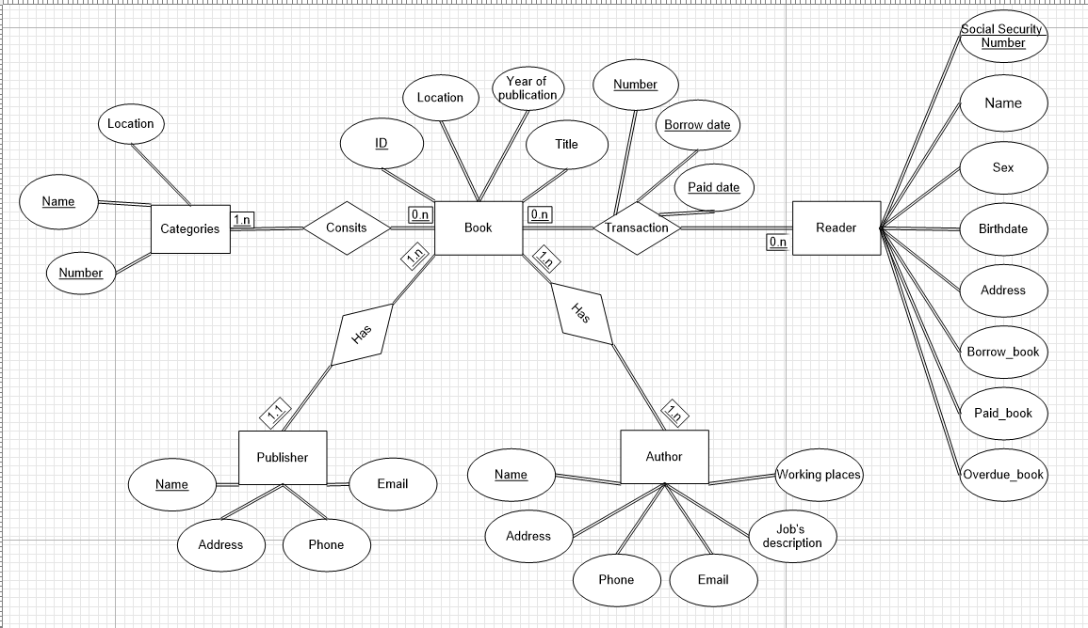

**2. Convert the above ER schema into relational data model.**

Category(Number, Location, Name)

Book(Identification number, Status, Location, Year of publication, Title,PublisherName)

Reader(Social security number, Address, Sex, Birth date, Name, Number of borrowed books, Number of paid books, Number of overdue books)

Publisher(Name, Address, Phone, Email)

Author(Name, Address, Phone, Email, Job’s description, Working places)

Transaction(Social security number, Identification number,Number,Paid date,Borrowed date)

Consists(Category Number, Identification number)

Write(AuthorName,IdentificationNumber)